Lucas Swanson
10/5/2025
Programming Languages I
Exercise 1
Exercise 1.1: BNF
Write a BNF grammar for the following language:
The set of all strings consisting of the keyword begin, followed by zero or more statements with a semicolon after each one, followed by the keyword end. Use the non-terminal <statement> for statements, and do not give productions for it.
G1: <string> : : = begin <statements> end
<statements> : : = <statement> ; <statements>| <empty>
Or EBNF:
<string> : : = begin { <statement> ; } end

Exercise 1.2: Ambiguous Grammars
Show that the following grammar is ambiguous. (To show that a grammar is ambiguous, you must demonstrate that it can generate two parse trees for the same string.)
<person> ::= <woman> | <man>
<woman> ::= wilma | betty | <empty>
<man> ::= fred | barney | <empty>

Here, some ambiguity stems from both the <man> and <woman> productions have a common term: <empty>. This could result in an empty string that we could parse in two different ways, a <man> or <woman>.
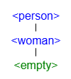 Or: 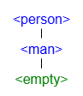
Exercise 1.2 Cont:
This could easily be resolved by moving the common token <empty> upwards into the production just before the split with <man> and <woman>.
<person> ::= <woman> | <man> | <empty>
<woman> ::= wilma | betty
<man> ::= fred | barney

Exercise 1.3: Python Grammar
Create a text file named exercise01.py. In this file, write a syntactically-correct program that meets the following criteria.
- Define a class that represents something that you are passionate about. For example, if you are interested in animals, you might define a Koala class. Ensure that the class has:
  - An idiomatic, parameterized initializer that initializes two properties. (For example, width and height. But, please, use appropriate, well-named properties - not width and height.)
  - A stubbed method named render. A "stub" is an empty method that does nothing.
- Create a well-named list filled with object instances of the class you have defined. This list should contain a random number of objects, but more than ten and less than twenty objects. Please use a for loop. By "well-named," we mean that your list should not be named list, mylist, objects, stuff, etc. Use a specific name that respects the kind of objects it contains.
- Prints a single line message, "There are an X number of objects in the list." Where X is either "even" or "odd." Please use an if statement, len, and an f-string.
- Ensure that the very first line of the file contains a single-line comment, containing your full name.
- Ensure that the file ends with a single blank line.
Now, using the full Python grammar specification as a reference, draw both a parse tree and an AST representation of your program.

Exercise 1.3 Cont:
When creating your parse tree, do not go deeper than two levels below simple_stmt or compound_stmt.
For the code, I have uploaded in one ZIP file along with this word document.
Parse Tree for Python Code:
This is brutal to try and see without expanding the image further than the screen will allow so I will truncate the items attached to the “For” statement and show in another image:
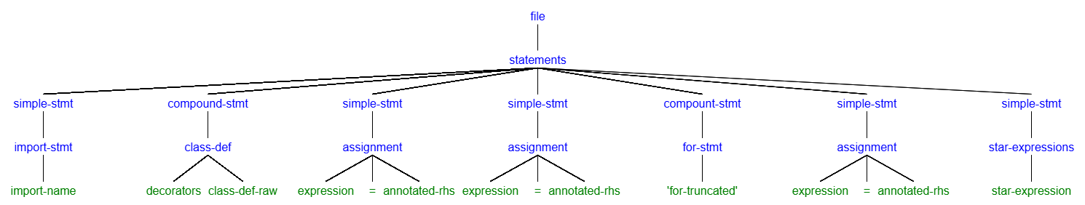
This parse tree showcases how the attached code (“exercise01.py”) is organized.
For the AST representation of my code, unfortunately it would be too wide to show in one screenshot here. So instead I will only go as deep as the parse tree went and I will include an attached generated AST file from python after entering my code into the imported library “ast” as described in the extensions section:
AST:
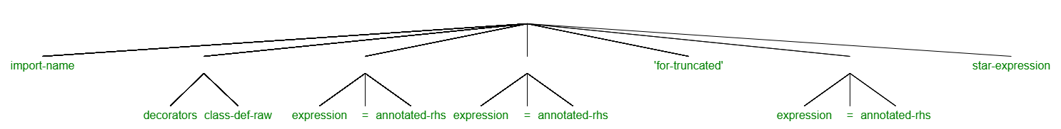

Exercise 1.4: Python Grammar II
The Python pass keyword represents one of Python's most simple statements. Using the Python grammar specification, propose two additional keywords that are equally simple, and explain why. In your explanation, make use of vocabulary terms as appropriate.
The keyword ‘pass’ is easily identifiable as one of Pythons most simple statements because it is one of only three keywords under the production for ‘simple_stmt’ exists a bunch of non-denominational tokens and three kewords. The first being ‘pass’, but the other two most simple statements in python are ‘break’, and ‘continue’ as of python 3.13.7 (subject to change in the future).

